S.No | Name | Designation | Qualification | Faculty Id | PHOTO
 | Dr. RAJU MERUGU | Professor | M.PHARMACY,Ph.D | 3495-180201-150702 | 
 | Dr.RAMA NARSIMHA REDDY ANREDDY | Associate Professor | M.PHARMACY,Ph.D | 3624-150409-132438 | 
 | SRIDHAR PADAM | Associate Professor | M.PHARMACY | 3987-150409-213201 | 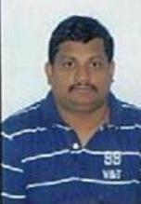
 | RENIKUNTA NIKHITHA | Assistant Professor | M.PHARMACY | 4846-171226-161513 | 
 | PALLERU KALADHAR | Assistant Professor | M.PHARMACY | 9813-171226-204018 | 
 | BOMMAKANTI RAMYAKRISHNA | Assistant Professor | M.PHARMACY | 4405-180419-195102 | 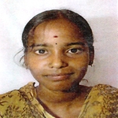
 | TIRUPATHI BHUKYA | Assistant Professor | M.PHARMACY | 2728-150414-142423 | 
 | DUMPALA NAVALOKA | Assistant Professor | M.PHARMACY | 5023-160310-103421 | 

